Revision History

Table of Contents

Use-Case Realization Report
Add Question

Issue <1.0>
Revision History
Date | Issue | Description | Author
<dd/mmm/yy> | <x.x> | <details> | <name>

Table of Contents
1. Brief Description 5
2. Flow of Events 5
2.1 Standard Workflow 5
2.2 Exceptions 5
3. Interaction Diagrams 6
3.1 Collaboration Diagram for Add Question 6
4. Participating Objects 6
5. Class Diagrams 7
5.1 Class Diagram for Add Question 7
6. Derived Requirements 7

Use-Case Realization Report
Add Question

Brief Description
This use case enables Portal Admin to add a question, which consists of question text, and the answers, as well as the correct answers.

Flow of Events

Standard Workflow

Portal Admin enter the information required for creating new question, including question level, question id, and question text.

Portal Admin selects the Question Type, either it’s radio button or checkbox.

Portal Admin enters the number of options, and click button “Go”.

According to the number of options, the page will be refreshed to show rows of options to be input.

Portal Admin will input the content of the options, and mark whether the option is correct answer.

Portal Admin then click “Add” button, the question will then be added.

Exceptions

When clicking the “Add” button, If Portal Admin inputs wrong data in the fields, e.g. does not give any content for question text, the page will display the error message.

When clicking the “Add” button, if Portal Admin tries to add the question that duplicates with existing questions, an error message will be displayed.

When clicking the “Add” button, if Portal Admin inputs the duplicate options, an error message will be displayed.

Interaction Diagrams

Collaboration Diagram for Add Question
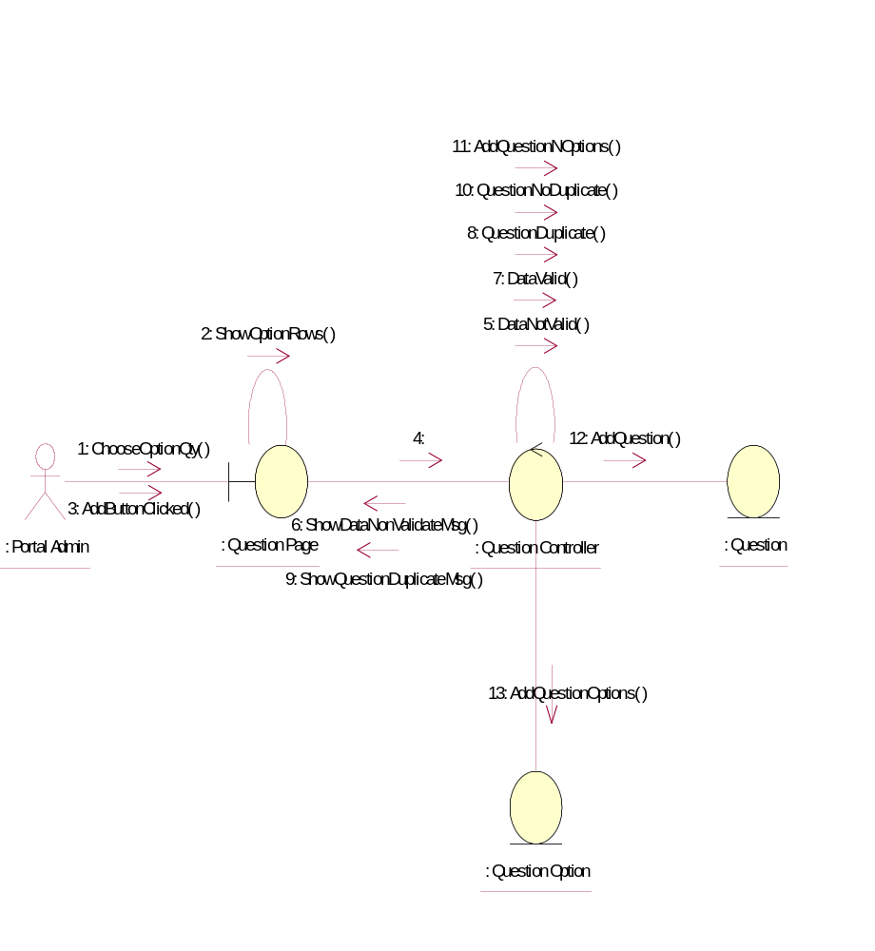

Participating Objects
: Portal Admin
This is the super user of the system.
: Question
This entity stores the details of the question.
: Question Controller
This control object is used to control the action to questions, e.g. add, delete or modify questions.
: Question Option
This entity contains the options of the questions, as well as mark what options are correct answers
: Question Page
This page provides an interface to add question into question pool.

Class Diagrams

Class Diagram for Add Question
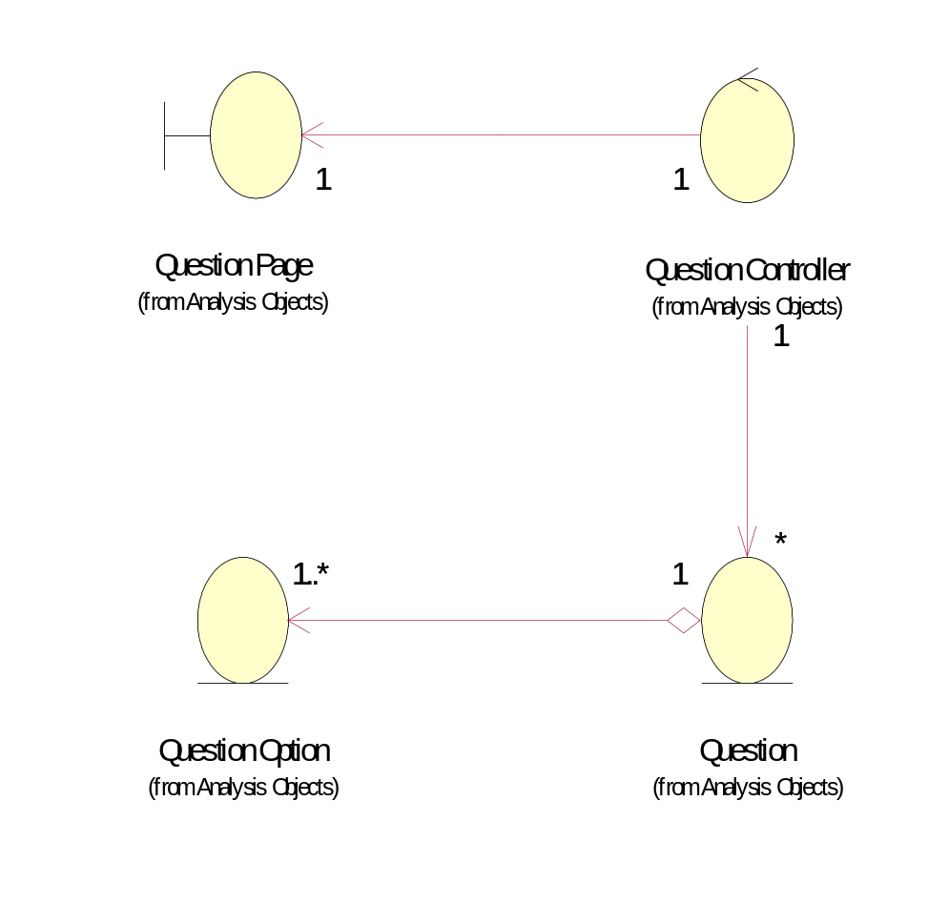

Derived Requirements
Only Portal Admin has access to this page.

